Foundation for Virtual and Augmented Reality Systems
Prof. Samit Bhattacharya
Department of Computer Science and Engineering
Indian Institute of Technology, Guwahati
Week – 12
Lecture – 59
VR resource optimization
Hello and welcome to the NPTEL MOOCs course on Foundation for Virtual and Augmented Reality Systems. We are going to conclude our discussion on resource optimization, particularly VR resource optimization, with this part of the lecture. So, we have talked about the basic idea of computer graphics, then the 3D pipeline, the computer graphics pipeline that we can envision to render a static image on a screen, just to demonstrate the computational complexities involved in the rendering process and the stages of the pipeline, also how the pipeline can be implemented in software through software libraries and in hardware using GPU and graphics card.
So, in this lecture, let us try to see how this knowledge can help us make decisions while building practical systems. So, in order to understand how we can use this idea in practice, let us revisit our Majuli case study, which we have discussed earlier. Just to recap, this is a river island on the river Brahmaputra, which is in the eastern part of India, as shown here on the map. The island is here in India and is surrounded by the Brahmaputra and its tributary. It is the world's largest inhabited river island.
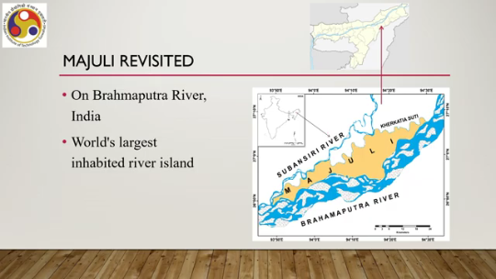
Our objective is to create a virtual tour of the river island so that the visitor in the virtual tour can perceive or can experience the ecological and cultural, both tangible and intangible, cultural heritage of the island. Now, earlier we talked about the different points of interest on the island. These are the information points on the island. So, a large number of points are there, which include Shatras or Vaishnavite monasteries, villages,
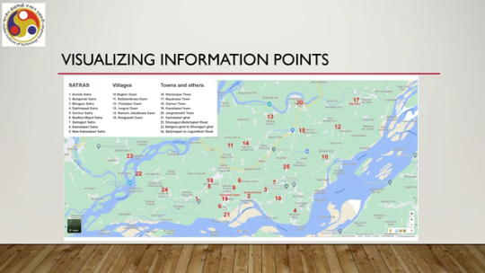
Tribal villages, and there are towns and other places of interest. So, a large number of points, each point is having a geographical spread. So, there are a large number of points of interest in each point as well. So, two levels of vast information: one is the whole island; the other one is each information point in the island also contains a large amount of data of interest.
So, we want an interactive virtual tour, a virtual reality tour of the island, an immersive experience, which is a combination of exploration techniques. Because the geographical spread is large, single techniques such as walking may not be good, or only teleportation may not be good to give a good feeling. So, we require a combination of exploration techniques. Now, what we did was to use a walking-based technique, a navigation technique at each information point, and a teleportation technique or vehicular movement technique, a navigation technique across points on the island.
So, within a point we use walking for navigation; between points we use teleportation or travel through a vehicle metaphor. So, these are the combination of navigation techniques we use to explore the whole island. And at each spot, the objective is that it should reveal all related information, including the heritage information, and let the user use such information interactively, and the user can interactively explore the place. So, in order to achieve the objective, we have collected a multimodal archive of information, which included regular and 360-degree images plus videos to capture indigenous architectural heritage of Satras and village life, 3D models for landscape and architecture, 2D drone shots to showcase landscape including flora and fauna because ecological heritage also we wanted to capture. then 2D videos to depict cultural or intangible heritage plus textual description. So, all this information together constituted the whole application because the amount of information is vast. So, the application size also became quite large, almost 10 gigabytes.
Now, the challenge was to render the content and allow the users to interact. Now, as we have already seen, Rendering such vast content involves lots of computation because if you note here, we have multimodal content rich in details, and the implication of such content is that we require significant computational support to render it efficiently in real time so that the immersive experience is realistic. So, we require fast storage and retrieval support as well as high computational support because the rendering process will be complex.
Earlier we talked about rendering simple static images, which itself was computationally intensive, and here we are having rich multimodal content which can be interactively changed and includes videos and animations. So, the computational requirement is many times higher. Our regular systems cannot support such an application having almost 10 GB of content, rich multimodal realistic content. So, we had to go for some optimization technique.
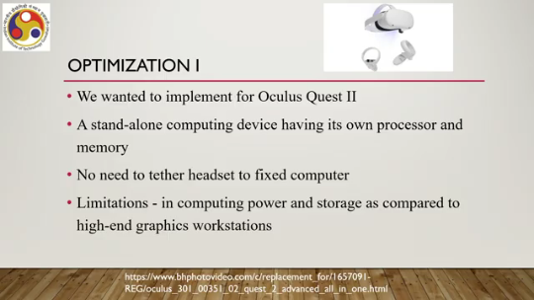
So, let us talk about two such techniques. Optimization 1: here we wanted to implement our system for the Oculus Quest 2 application. The device, as shown here, comprises a headset and handheld controllers. Now, the Oculus Quest 2 is a standalone computing device having its own processor and memory. We do not need to tether it with any computer.
No need to tether the headset to a fixed computer. But the limitation is that its computing power is less as compared to a workstation. And storage is also relatively less compared to a workstation, a high-end graphics workstation. So, then we had to go for some optimization strategy to reduce the size of the application and also associated computations, including memory access.
So, if we reduce the size, then the requirement for rendering will be reduced, which also involves the requirement for accessing data from memory for rendering. Now, what strategy did we use? We used a cloud computing-based approach. So, we use the cloud to store all the videos, not the images, but the videos, because videos take up more space.
When the user selects a video thumbnail from the video player in the Quest, that is the video player interface provided within the immersive environment, as we have discussed earlier in the implementation part of the lecture, the corresponding video is loaded from the cloud. So, the video is not stored locally, so the storage requirement is less, and the accessing requirement is less. Accessing operations are also computationally intensive. So, the fewer the operations, the better.
So, this led to a reduced application size of 5.1 GB. So, because some parts, the videos, are stored in the cloud. So, the application deployed on the client device, that is the Oculus Quest 2, is reduced to 5.1 GB, and a corresponding computational reduction happened. However, because we are relying on a cloud server, cloud services, there were additional concerns apart from rendering, that is particularly related to network connectivity.
In order to load the high-quality videos on a real-time basis, we required high bandwidth support and also network coverage. Latency should be minimal. So, if these issues are not resolved, then cloud-based optimization would not be of much help. However, this is just to show that to take care of optimization concerns in rendering, we can recourse to different technologies so that rendering optimization can take place. That may lead to other concerns which we also need to address.
Now, let us talk about another optimization. We also wanted to implement for everyday smartphones; that is, we wanted to deploy it on a smartphone and put it in a cardboard for an immersive experience, as illustrated in this figure. So, we have this cardboard type of system within which we can put our smartphone and if we create stereoscopic views, then when we wear it as a headset, we get to see an immersive environment without using any expensive headsets. Cardboards are very cheap, only about 500 to 1000 rupees, Indian rupees.
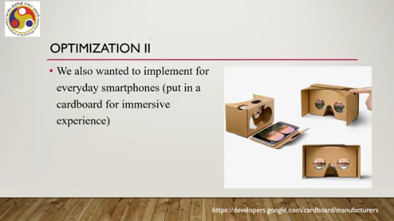
And everybody has smartphones, so if we deploy, then we can have a ready-made immersive experience without spending too much money on the appropriate device. However, in order to do that, we had to go for some optimization strategy because the size is more than what typically smartphones support and the associated computation also; typically, smartphones do not support such a high amount of computation, average smartphones. So, we had to go for some other optimization strategy.
In this case, what we did is we did compression. We compressed the images that we have to reduce the storage requirements, and we could not utilize the videos, most of the videos. So, video playback support was removed. So, together what they resulted in is a kind of less realistic experience as compared to a full version implementation.
But with these optimizations, we could reduce the overall size to 0.7 GB from roughly 10 GB. As you can see, it is much less. We could have also explored cloud-based support as well, cloud-based solutions as well. So, in that case, video playback we could have kept. However, you can try it at your end for large applications. So, the idea here is just to show that in order to take care of computational issues associated with rendering immersive experiences, we can take recourse to different approaches such as taking cloud-based services or going for compression techniques. And in extreme cases, we may have to remove some features. So that is what we can do in practice because we know that if we try to deploy the whole system for any platform, then it is not possible. It will lead to problems.
And why will the problems come? Now we have a foundation to understand that. That is because rendering will not be possible. with any device. So, let us summarize what we have learned.
So, we have talked about the idea of resource optimization in virtual reality. In order to understand that, we introduced computer graphics, basically the pipeline stages, the 3D graphics pipeline, its stages and its implementation in software as well as in hardware. where we explained what a GPU is, how it is organized, and how it is used to implement the stages. And also we talked about how such knowledge is useful in practice. So, in this entire lecture on immersive experience, we referred to several concepts.
We did not go into the details of those, particularly related to computer graphics, as the objective was to keep it simple. bare minimum things for your understanding. However, you can refer to this book, Computer Graphics by Oxford University Press, written by myself to know more details about the topics covered. All the topics I have taken from that book only. Also, there is one NPTEL MOOC course offered by me on Computer Graphics, which again covers all the topics mentioned here.
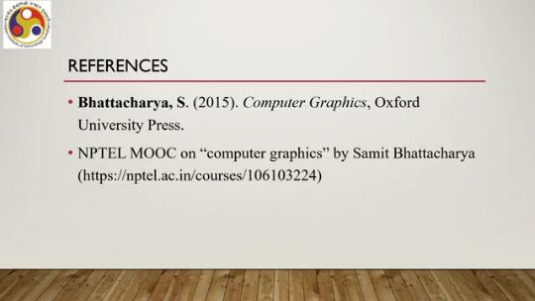
So, you can also go through the modules of that course to know in more detail about the stages. So, I hope you could follow the overall idea of the resource optimization concept and why computer graphics is relevant and how we can understand the rendering process complexities and how that knowledge can help us take decisions. in deploying systems. So, looking forward to meeting you in the next lecture. Thank you, goodbye, and happy learning.

